**IOT PHASE-4**

**SMART WATER MANAGEMENT**

**MAJOR COMPONENT’S PICTURE USED IN THESE PROJECT:**

1. **RASPBERRY-PI:**

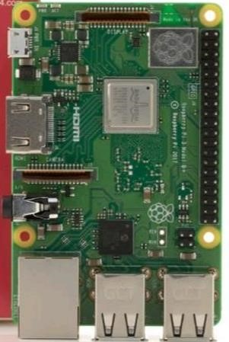

1. **ULTRA SONIC SENSOR:**

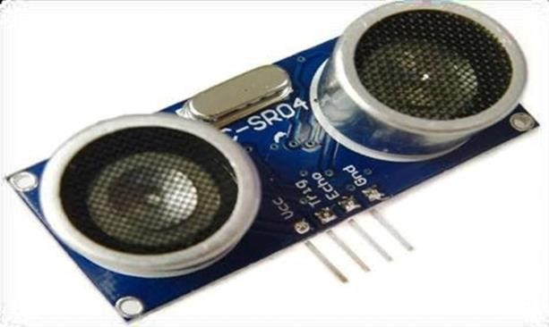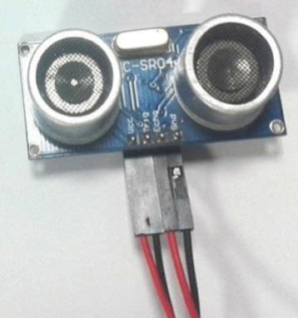

**ULTRA SONIC TRANSMITTER-FUNCTIONAL BLOCK DIAGRAM**

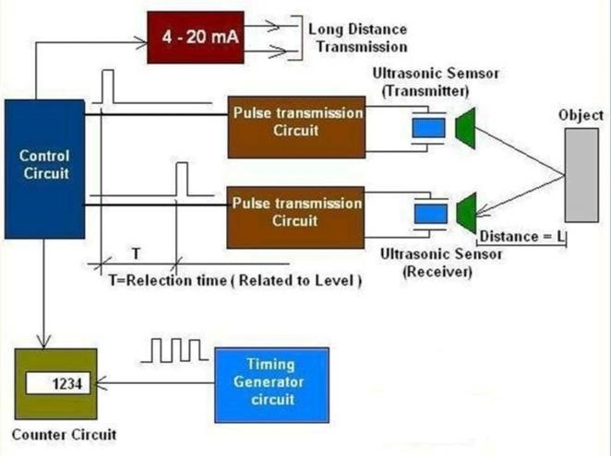

**3.RELAY:**

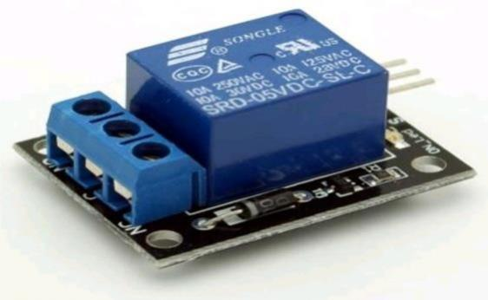

**Features of 5-Pin 5V Relay:**

* + Trigger Voltage (Voltage across coil) : 5V DC
  + Trigger Current (Nominal current) : 70mA
  + Maximum AC load current: 10A @ 250/125V AC
  + Maximum DC load current: 10A @ 30/28V DC
  + Compact 5-pin configuration with plastic moulding
  + Operating time: 10msec Release time: 5msec
  + Maximum switching: 300 operating/minute (mechanically)

**FLOWCHART FOR SMART FAUCET SYSTEM:**

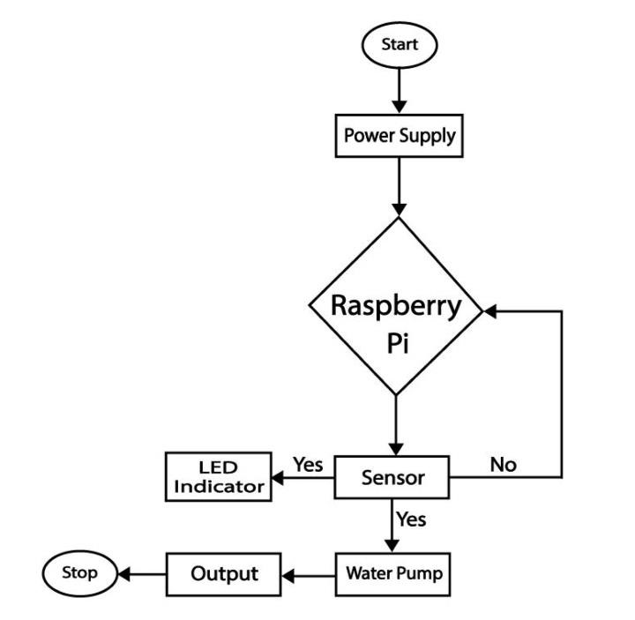

**OVERALL SERIES OF TOOLS:**

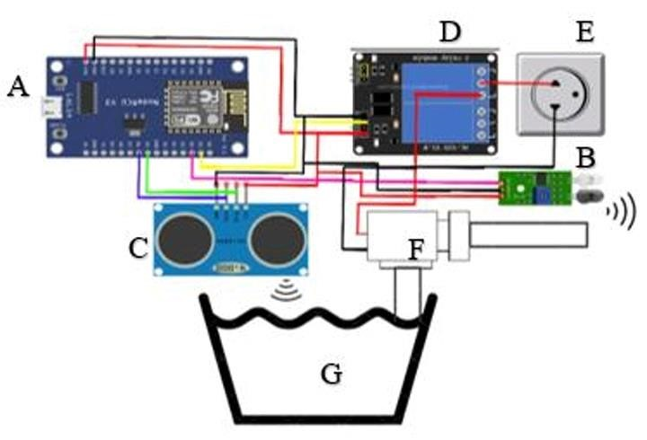

**WORKING OF THE SYSTEM:**

The Concept behind the Smart Tap System is very simple. I will use a HCSR04 Ultrasonic Sensor to check if any object such that the glass is placed before the tap (dispenser). A solenoid valve will be used to control the flow of water, which is when energised the water will flow out and when de-energised the water will be stopped. So I will write a python program which always checks if any object is placed near the tap, if yes then the solenoid will be turned on and wait till the object is removed, once the object is removed the solenoid will turn off automatically thus closing the supply of water. The solenoid valve used in this project is a 12V valve with a maximum current rating of 1.2A and a continuous current rating of 700mA. That is when the Valve is turned on it will consume about 700mA to keep the valve turned on. As we know an Arduino is a Development board which operates with 5V and hence we need a switching driver circuit for the Solenoid to turn it on and off. The Ultrasonic Sensor is powered by the +5V and ground pins of the GPIO pin. The Echo and Trigger pin is connected to the GPIO pin 8 and pin 9 respectively. I can then program the Raspberry pi to use the Ultrasonic sensor to measure the distance and turn on the MOSFET when an object is detect. The whole circuit is simple and hence can be easily build on top of a breadboard. Mine looked something like this below after making the connections.

JAVA SCRIPT

class WaterTankIoTDevice {

constructor(initialLevel) {

this.level = initialLevel;

}

updateLevel(newLevel) {

this.level = newLevel;

}

}

class AlertingSystem {

sendAlert(message) {

console.log(`ALERT: ${message}`);

}

}

class WaterManagementSystem {

constructor(device, alertingSystem) {

this.device = device;

this.alertingSystem = alertingSystem;

}

checkWaterLevel() {

const currentLevel = this.device.level;

if (currentLevel <= 10) {

this.alertingSystem.sendAlert("Water level is critically low! Please refill the tank.");

}

}

updateWaterLevel(newLevel) {

this.device.updateLevel(newLevel);

this.checkWaterLevel();

}

}

const waterTankDevice = new WaterTankIoTDevice(50); // Initial water level is 50 units

const alertSystem = new AlertingSystem();

const waterManagementSystem = new WaterManagementSystem(waterTankDevice, alertSystem);

function simulateDataUpdates() {

setInterval(() => {

const newLevel = Math.floor(Math.random() * 100); // Simulated new water level

waterManagementSystem.updateWaterLevel(newLevel);

}, 5000); // Simulate updates every 5 seconds

}

simulateDataUpdates();

PROJECT SUBMITTED BY:

NAME:NALLAGONDU SREENUVASULU NAIDU

REGISTER NO:713921106030

TOPIC: SMART WATER MANAGEMANT

MAIL ID:sreenu1713257@gmail.com

NM ID:au713921106030

COLLEGE CODE: 7139